**WeatherbyGreg.com**

**Site Plan**

**Site Name**

Weather Watch with Greg

https://weatherwatchwithgreg.com

**Site Description**

The site’s purpose is primarily to provide weather information for the towns of Preston, Soda Springs, and Fish Haven in Southern Idaho. General information and news about each town is also provided. A storm center page will give information on storms in the area covering lands in between and beyond the three individual towns.

**Target Audience**

The audience for WeatherWithGreg will vary greatly since almost anyone could be interested in looking up the weather at any given moment. General audience expectations are given below:

**Age:** 12 years old and up, but majority ages 18-80.

**Topic experience:** Majority of the audience will be from the southern Idaho area who should be familiar with the weather patterns in the area and are only looking for daily specifics. A smaller percentage will be from out of the area and looking for more information about the area in addition to weather.

**Access type:** It is expected that about half our audience will access our website through mobile devices and half through larger screen desktop computers.

**Personas**

**Calvin Johnson**

**Age:** 22

**Residence:** Salt Lake City, Utah

**Purpose for site use:** He is planning a fishing trip and is checking the forecast for the areas he is interested in going to. Depending on the weather, he may choose one location over another. He will check the site daily for updates for a few weeks leading up to his trip, and during his stay in the area.

**Technology used:** He will use his desktop computer at home while planning the trip. Once he leaves home he will exclusively use his phone. He will likely use his phone occasionally during his trip-planning phase as well.

**Susan Wilson**

**Age:** 63

**Residence:** Soda Springs, Idaho

**Purpose for site use:** She is checking for when the weather will be warm enough to go out and begin her spring time gardening and yard care. She lives in the area and knows the general weather patterns, but wants to keep an eye on the forecast to be sure that a few days of warm weather isn’t going to be followed up by one last weekend of frosty temperatures. She will check the site occasionally. Being a local, she will probably be interested in the related news articles for the area that will accompany the weather information.

**Technology used:** She has a smartphone, but doesn’t use it for browsing the internet. She will check the website exclusively from a desktop computer.

**Scenarios**

1. Will it be sunny enough today for taking the kids to the park?
2. I’m just curious about the weather, what’s the overnight low going to be?
3. Can we plan to have an outdoor bbq with the family this weekend?
4. Will it snow this weekend when travelling through the area?
5. I want to go hiking near Fish Haven in April, how likely is it to rain?

**Site Map**

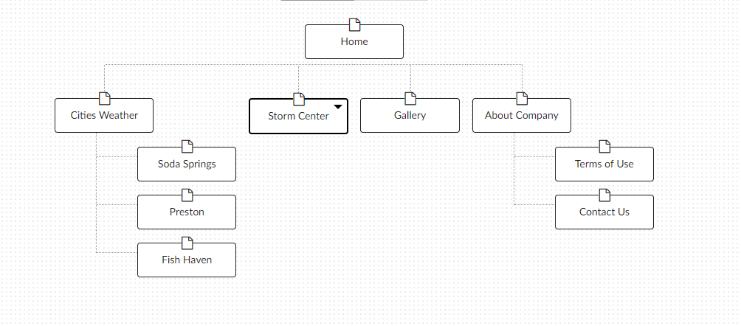

**Color Scheme**

619176: Background color for main text/paragraphs

1A5232: Navigation boxes background color

743524: Navigation Text color and links text color in paragraphs, footer links, etc

541C0E: Activated/clicked on links text color

0A3C20: Darker color to designate what city page you are on. Also will be used as borders/padding colors for boxes of text, photo borders, navigation box borders, etc.

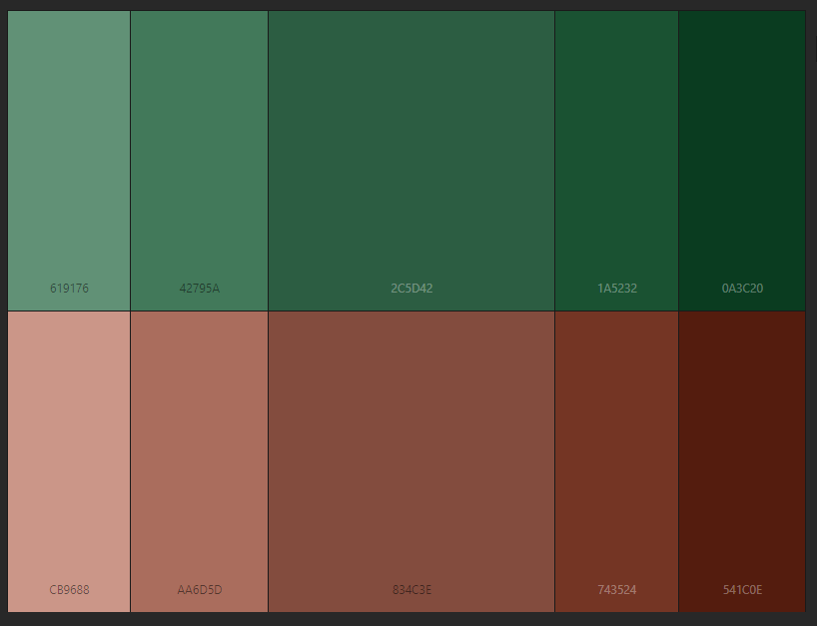

**Typography**

|  |  |  |
| --- | --- | --- |
| **Type of Text** | **Font** | **Size** |
| Standard text (paragraphs) | Georgia | 12px |
| Navigation | **Georgia Bold** | 16px |
| Headings H2 | **Georgia Bold** | 16px |
| Headings H3 | Georgia | 14px |
| Links in text | *Georgia Italics* | 12px |